**JWST MAGIC: User Guide**

**The Multi-Application Guiding Interface for Commissioning**

September 2018

POC: Lauren Chambers ([lchambers@stsci.edu)](mailto:lchambers@stsci.edu)) or Keira Brooks (kbrooks@stsci.edu)

*Special notes for users:*

* If something is not working as is stated in this guide, please submit an issue on <https://grit.stsci.edu/wfsc/tools> (accessible from WFSC Guiding console – make sure you log in as yourself using your AD username and password) using the “Issues” button on the left-hand side of the page. Please specify that it is for this tool and be specific about the problem that you ran into.
* If the issue you are having is preventing you from completing your task, immediately contact Keira Brooks ([kbrooks@stsci.edu](mailto:kbrooks@stsci.edu), x6821) or Lauren Chambers ([lchambers@stsci.edu](mailto:lchambers@stsci.edu), x6517).

______________________________________________________________________________

**Table of Contents**

1. Setting Up
2. Getting the Input NIRCam Image from the DAN Server
3. Selecting Guide & Reference Stars for an Input NIRCam Image
4. Opening DHAS
5. Testing Selections in DHAS
6. Contingency: Re-selecting Stars and Re-running DHAS
7. Writing the Segment Guiding Override File
8. Getting the JWST MAGIC Package on your Machine
9. **Setting Up**
10. If you have not yet installed the tools, go to Part VIII, “Getting the JWST MAGIC Package on your Machine”
11. Check that you are in your astroconda environment.
12. Make sure that you have the most up-to-date version of the tools (pull the most recent version of the tools from the repo):

$ cd /Users/<username>/tools

$ git pull origin master

1. **Getting the Input Image from the DAN Server (from SOGS only)**

Note: If you are on your own machine and not in SOGS, and/or not using this for a commissioning rehearsal, you can grab any FGS image or a NIRCam image that was taken with the CLEAR filter (a WL filter will crash MAGIC)

1. To get the input image, navigate in a Terminal window to where you want the files saved and type the following

$ cd /data/jwst/wss/shadow/calSci/data

$ ls

1. Confirm with WSS Optics Sim that the files in this location are the correct files for this commissioning activity.
2. If all of the files are correct (check with WSS), copy all of the images to the WFRSeptember2018 folder during the setup of the system (following instructions in the WF Guiding Shift Set Up and Break Down document). In the path below the CAR is the CAR name and number in lowercase, i.e. ote13.

$ cp * /data/jwst/wss/guiding/wfr_september_2018/{CAR}/

If there are multiple files, you want to choose the file where the image has the PSFs in the configuration that you are expecting, this is usually the last image (you can check this by looking at the file names). If you still aren’t sure, check with WSS or WF Ops.

1. **Selecting Guide & Reference Stars for an Input Image**
2. Once you are in the astroconda environment, start an IPython session and launch the main GUI:

$ ipython

In [1]: import jwst_magic

In [2]: jwst_magic.run_tool_GUI()

The main GUI should appear:

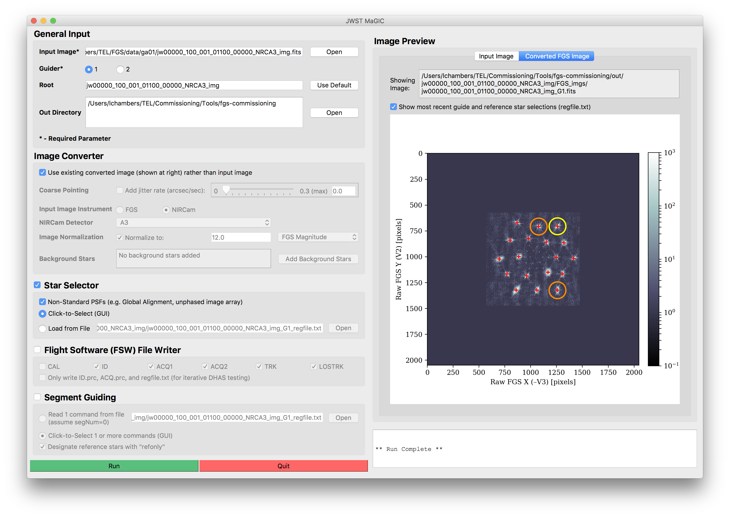

Figure - Main GUI for the JWST MAGIC Tool

1. Set general input parameters:



**D**

**C**

**B**

**A**

Figure - General Input section of the Main GUI

* 1. **Load the input image.** **A**  If you completed Part II, it should be located at /data/jwst/wss/guiding/wfr_september_2018/{CAR}/

{NIRCam_filename}.fits, where ote{#} is the OTE number as defined in Part II.

A preview of the image and the full path to the image will appear in the Image Preview box at right.

* 1. **Specify the guider** **B**  that the final image should simulate. If this is not clear, check the APT file.
  2. **Specify a root name** **C**  , if different than the default name that was created when the input image was uploaded. The root will be used to to create the output directory where all created files will reside, out/{root}.
  3. **Change the out directory** **D**  **,** which determines where the out/ directory will be placed, to /data/jwst/wss/guiding/wfr_september_2018/{CAR}/

Considering these parameters all together, the output files will be saved in the {out}/out/{root}/ directory, with names of the format {root}_G{guider}....

1. Set image conversion parameters: (Note: The steps labelled “optional” below wil create higher fidelity images but are not necessary for image testing at this stage)



**E**

**D**

**C**

**A**

**B**

Figure - Image Converter section of the Main GUI

* 1. (Optional) **Simulate the effects of coarse pointing** **A**  by specifying the jitter rate of the observatory. A jitter rate of 0.7 arcsec/sec creates images that are similar to ITM simulations in coarse point. Otherwise, ensure the “Add jitter rate” box is unchecked.
  2. Check that the **instrument** **B** **and NIRCam detector** **C** used to take the input image are set to the correct values; change them if not. (If the NIRCam detector is not defined, the tool will attempt to parse it from the input FITS header.) The FGS-formatted image will be saved to out/{root}/FGS_imgs/{input_image}_G{guider}.fits
  3. (Optional) You can specify the **magnitude or counts for the normalization** **D** of the final image. Otherwise, ensure the “Normalize to” box is unchecked.
  4. (Optional) **Add background stars** to the final image.
     1. Click “Add Background Stars”. **E** The background stars dialog box will appear:



**C**

**B**

**A**

Figure - Background stars dialog window

* + 1. Select which method you wish to use to add stars to the image: randomly, with a user-defined table, or with a Guide Star Catalog (GSC) 2.4.1 query.
       1. To add stars randomly:
          1. Select the **“Add Stars Randomly”** **A** checkbox.
          2. Input the number of stars you want to add to the image
          3. Specify the magnitude range that these additional stars will lie between (relative to the magnitude of the guide star)
       2. To add stars individually:
          1. Select the **“Define Stars to Add”** **B** checkbox.
          2. If you wish to load star locations and brightness from a file, indicate the location of that file.
          3. Otherwise, enter into the table the X position in pixels, the Y position in pixels, and the countrate in J Magnitude of each star you wish to add. Click the “Add Another Star” button to add another row to the table, or the “Delete Star” button to remove a row.
       3. To add stars using a web query from the Guide Star Catalog:
          1. Select the **“Query Stars from Guide Star Catalog 2.4.1”** **C** checkbox.
          2. Enter the RA and Dec of the guide star, being sure to specify if the RA units as either hours or degrees.
          3. Enter the position angle (roll angle) of the observatory.
          4. Click the “Query GSC” button to add the stars that are visible in the FOV of the selected guider.
    2. Click “Done” to save and apply these selections, or click “Cancel” to close the window without updating the background star selections.
    3. Verify that the indicator shows that thcorrect number of background stars have been added.

1. Set star selection parameters:



**B**

**A**

Figure - Star Selection section of the Main GUI

* 1. Ensure the “Star Selector” box is checked.
  2. Inspect the input image and **indicate if the PSFs are non-standard**. **A**  This flag alters the PSF-finding algorithm in the star selector tool to widen the smoothing filter for diffuse images in early commissioning stages.
  3. If desired, **load pre-selected guide and reference stars from a file** **B**  by selecting the “Load from File” option and selecting the desired input file. This file must include X/Y pixel coordinates and count rates in the form of a filepath to a regfile.txt or .incat file. Providing this will bypass using the Star Selection GUI to click-to-select the guide and reference stars.

1. Set file writer parameters:

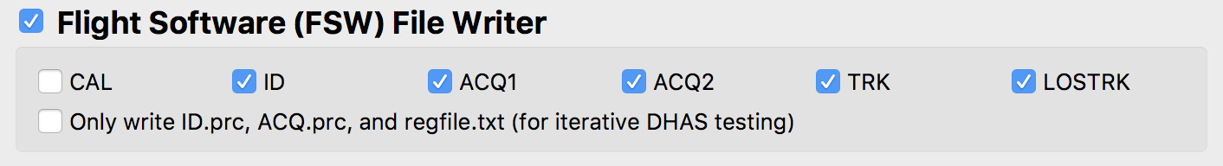

Figure - Flight Software file writer section for the Main GUI

1. Ensure the “Flight Software (FSW) File Writer” box is checked.
2. Check that all of the **necessary FGS steps** are selected. This should be the case, as the default parameters include all of the operational steps.
3. Run the tool



1. Monitor the terminal window from which you launched the GUI to notice any possible errors that are raised.

*Note:* The output that appears in the command line is also written to

/Users/<username>/tools/fgs-commissioning/logs/

1. When the Star Selection GUI appears:

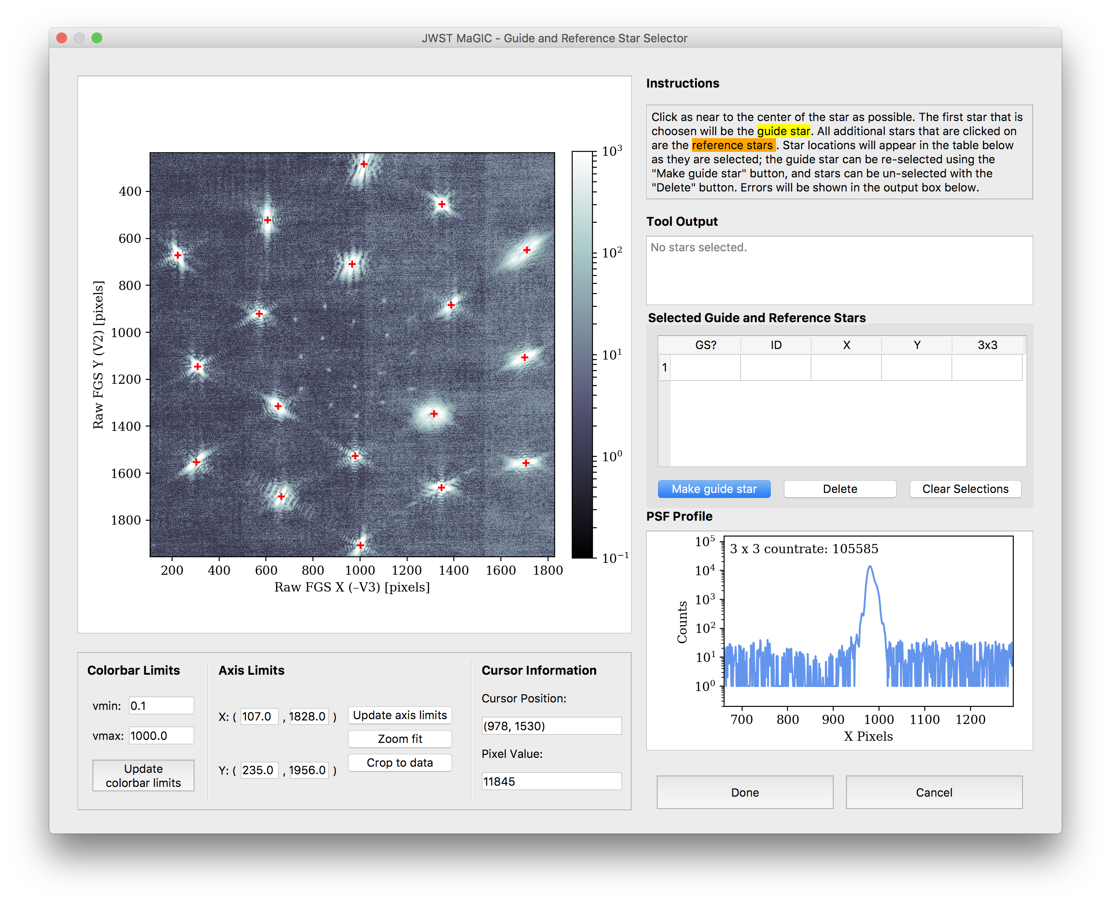

**C**

**B**

**A**

Figure - Star Selection GUI window

* 1. Inspect the PSFs in the image by moving your cursor over different PSFs. Examine the profile plot to see the distribution of light.
  2. Select, by clicking, which PSFs will be the guide star and the reference stars. The first star selected will be the guide star, while any subsequent stars will be reference stars.

*(Use Appendix D in the CAR procedures to choose the guide and referencd star based on PSF configuration)*

* + 1. Select the more compact or “peaky” PSFs rather than diffuse, noncontiguous or “blobby” PSFs
    2. Try to select some reference stars that are close to the guide star and some that are further away
    3. Do not choose reference or guide stars in regions where several PSFs are close together
  1. If you want to change your selections while in the tool, use the **“Make Guide Star”** **A**  button to change the guide star, use the **“Delete”** button **B**  to remove individual selections, and ust the **“Clear Selections”** button **C**  to start over.
  2. When you are happy with your selections, click “Done”

1. The output files will be located at

/data/jwst/wss/guiding/wfr_september_2018/{CAR}/{root}/



1. **Opening DHAS**
2. If you are working on SOGS and you have not already configured DHAS to work on your personal SOGS account, follow the instructions for setting DHAS up correctly on SOGS here: <https://innerspace.stsci.edu/display/INSTEL/Setting+up+the+DHAS+on+your+SOGS+account>
3. Find the MATLAB icon on the dock and double click to open MATLAB (or press CMD + space to open Spotlight and search for MATLAB)
4. In the MATLAB interface, if not already there, navigate to the DHAS, version 3.0 directory

$ cd /Users/<username>/Documents/MATLAB/dhas/v3.0/fitsdisp2_v3p0/

1. Start the DHAS GUI:

$ fitsdisp2

1. **Testing Selections in DHAS**



Figure : DHAS GUI

1. Load the IDstrips.fits file you just created:
   1. Click the blue “Load Multiple .FITS Files” button



* 1. Using the “Current Directory” drop-down menu (or by typing the path directly into the textbox), navigate to the out/{root} directory where the images have been saved. (In the above example, /data/jwst/wss/guiding/wfr_september_2018/{CAR}/out/GA_obs1_WFR/)
  2. Go the “dhas” subdirectory (In the above example, /data/jwst/wss/guiding/wfr_september_2018/{CAR}/out/GA_obs1_WFR/dhas/)
  3. Check the “Show All Files” box
  4. Select the IDstrips.FITS file (In the above example, GA_obs1_WFR_G1_IDstrips.fits)
  5. Click “Add →”
  6. Click “Done”

1. Run the ID simulator
   1. Click the corresponding G1 or G2 button depending on if this is a guider 1 vs. guider 2 image at the top of the page



* 1. Click the small pink “ID-sim” button at the top of the page



* 1. A finder window will appear with the expectation that the user will choose the appropriate .prc file (no text indicates this). For this step (ID) open the ID.prc file corresponding to the IDstrips.fits file that you selected (in the above example, GA_obs1_WFR_G1_ID.prc)
  2. When the star_catalog_page dialog box appears:
     1. Set the Row and Column values to be 12 and 0 (in the bottom left corner of the window), respectively (the X-Angle and Y-Angle values will automatically change to reflect this):



* + 1. If you want to alter your guide & reference star selections, do so here by toggling the “GS” (guide star) and “RS” (reference star) buttons
    2. Click the “Done” button.
  1. When the ID Mode Setup dialog box appears, click “OK.”

1. Wait for the simulator to run
2. When the finder window pops up, press “Cancel”
3. DHAS results: Commanded (CMD) reference stars are denoted by yellow triangles (∆). The commanded (CMD) guide star is denoted by a yellow cross/plus sign (+). The reference stars that the DHAS has found are denoted by blue x’s (x) and the guide star is denoted by a blue asterisk (*). See the screen shot below for an example of a successful DHAS run.



Figure : Example of a successful DHAS run

1. Inspect the DHAS results
   1. Do the stars that DHAS found (in blue) match the stars you commanded it to find (in yellow) If not, DHAS has **failed**.
   2. For more detailed DHAS diagnosis:
      1. Does DHAS think it successfully found the guide star? (Does “Status” equal SUCCESS?)
      2. Did DHAS find all of the stars? (Does “# Candidates” equal 18 – for GA or image array steps?)
      3. If necessary, click the “Export” button to more closely examine DHAS’s output plot and/or save the image as a .PNG
2. If all goes well, click the “EXIT” button in the DHAS GUI to exit the GUI and then type “exit” into the Command Window to close MATLAB

**If DHAS fails, we need to try a different orientation of guide and reference stars until we find a successful one. See Part VI.**

If DHAS is successful, move on to Part VII.

1. **Contingency: Re-selecting stars and Re-running DHAS**

When re-selecting stars for testing in the DHAS, not all of the files generated by the commissioning tools need to be rewritten; only the files that specify which segments are the guide star and reference stars need to be changed (namely, the ID.prc and regfile.txt files). Thus, though completely re-running the tool would work to re-select the guide and reference star segments (see Part III), it is not necessary. We have developed a faster method for re-selection and file rewriting, detailed here.

1. In the main GUI, select the “Only write…” button within the Flight Software File Writer box. All other options in the interface will be disabled.

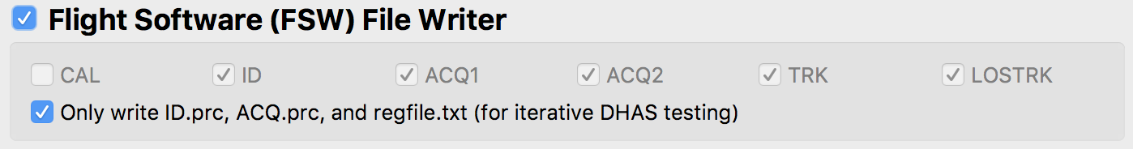

Figure - Flight Software file writer section of the Main GUI for the case when only the .prc files are over written

1. Run the tool:



1. When the Star Selection GUI appears, again examine your input image.

*Note:* If you prefer to analyze the image in DS9, you can do so by typing $ ds9 name_of_image.fits into the command line or !ds9 name_of_image.fits in IPython. Be sure to load the image in the folder /data/jwst/wss/guiding/wfr_september_2018/{CAR}/out/{root}/FGS_imgs/, which is your FGS image. Since DS9 displays images differently than Python, go to the Zoom menu in the menu bar of DS9 and select “Invert Y”.

Recall the suggested selection criteria (also see Appendix D in the CAR procedures):

* + 1. Select the more compact or “peaky” PSFs rather than diffuse, noncontiguous or “blobby” PSFs
    2. Try to select some reference stars that are close to the guide star and some that are further away
    3. Do not choose reference or guide stars in regions where several PSFs are close together

1. Select new guide/reference stars and click “Done”.

This step will overwrite the existing ID.prc and regfile.txt files with the new star commands.

1. Re-run DHAS (Part V)

**If DHAS fails again, we still need to try a different orientation of guide and reference stars until we find a successful one. Repeat** **Part VI****.**

If DHAS is successful, move on to Part VII.

1. **Writing the Segment Guiding Override File**
2. In the main GUI, select the “Segment Guiding” box. All other options in the interface will be disabled.

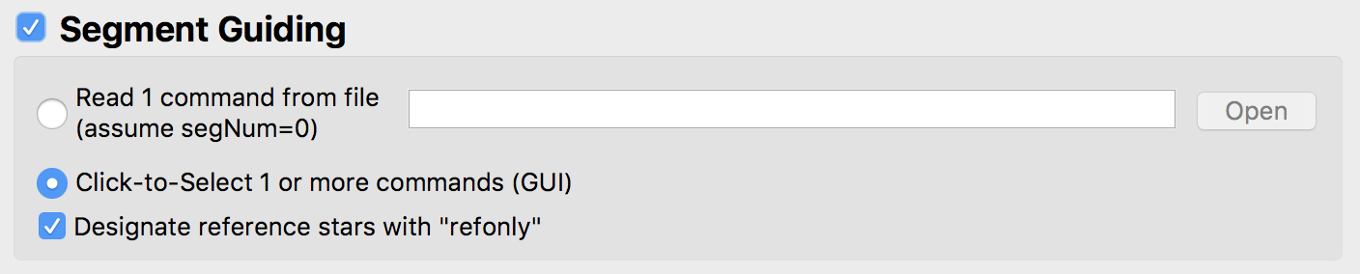

**A**

**C**

**B**

Figure - Sement Guiding section of the Main GUI

1. If desired, specify a file from which to load the locations and brightness of the selected guide and reference star by selecting the **“Read 1 command from file” radio button** **A**  and specifying the path to this file (most likely a regfile.txt or a .incat file). Providing this file will use only the guide and reference star selected by the user in step III and bypass using the Segment Guiding GUI, and you can skip to step 15 below.
2. Otherwise, select the **“Click-to-Select 1 or more commands (GUI)” radio button** **B**  to launch the GUI that will allow you to click-to-select multiple orientations of guide and reference stars.
3. Designate whether to mark reference stars in the segment guiding override file with the **“refonly” check box**. **C**  Unless something has broken in VSS, this should be checked.
4. Before running the tool, obtain the following parameters with the following methods:
   1. **APT parameters**: If you do not know, ask the wavefront scientist for the program ID, observation number, and the visit number.
   2. Guide star **RA** & **Dec**: Retrieve the guide star ID (e.g. N13I000017) from the APT file, under “Special Requirements” for the current observation. Look up this ID in the guide star catalog to determine the RA and Dec (<http://gsss.stsci.edu/webservices/GSC2/WebForm.aspx>; submit the guide star ID in the “HST ID” field).
   3. **Position Angle**: Ask the S&OC for the visit position angle at the guide star (V3PA@GS).
   4. Get the current **V2 & V3 boresight offset** from the wavefront scientist.
5. Run the tool:



1. 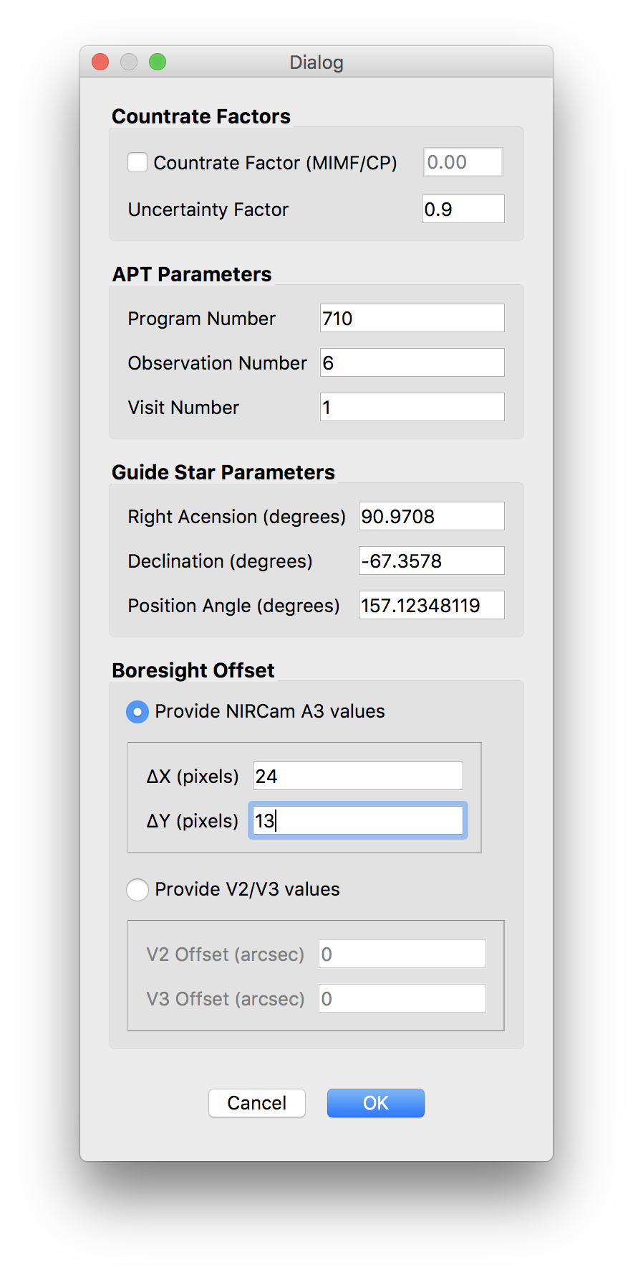When the Segment Guiding Dialog Box appears (shown at right), define the segment guiding parameters, including (Note: It is unlikely for WFR2 that the first two factors will be used) :
   1. **Countrate factor** – a factor between 0 and 1 that all segment magnitudes are multiplied by in the segment override file. Used for cases such as MIMF and CP when the segments are stacked but unphased, and so the brightness of the guide star is dimmed.
   2. **Uncertainty factor** – the degree of uncertainty in the countrate of each segment. E.g., an uncertainty factor of 0.9 for a star with a countrate of 1,000 writes an uncertainty of 900.
   3. **Program Number** – ID of the current APT program; three to five digits
   4. **Observation Number**
   5. **Visit Number**
   6. **Right Ascension** of the guide star
   7. **Declination** of the guide star
   8. **Position Angle** of the observatory
   9. **V2 Boresight offset**
   10. **V3 boresight offset**

Figure 12 - Segment Guiding Dialog Box

1. Click “OK” to continue.
2. When the Segment Guiding GUI appears:

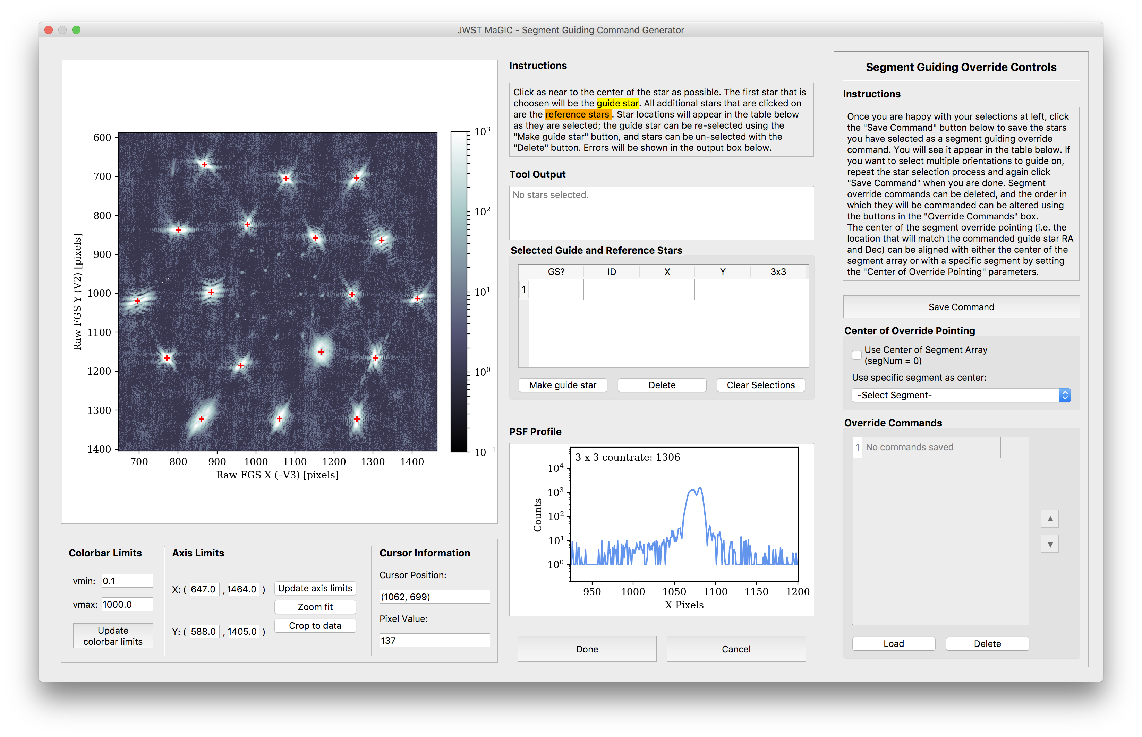

**F**

**E**

**D**

**C**

**B**

**A**

Figure - Segment Guiding GUI Window

1. Repeat the steps outlined in Part III to select the guide and reference stars for one segment guiding override command.
2. When you are happy with your selections, click the **“Save Command” button**. **A**  You will see the IDs of the stars you selected appear in the **“Override Commands”** table **C** .
3. To add another command, again repeat the steps outlined in Part III to select guide and reference stars, and again click the **“Save Command” button**. **A**  d
4. To change the order of the commands, use the **up and down arrow buttons**. **D**  To view a saved command on the plot, click the **“Load” button**. **E**  To remove a command from the list, click the **“Delete” button**. **A**  d
5. Select the **center of override pointing**. **B**  This sets the origin of the ideal frame (i.e. the location of the guide star if the segments were stacked). It can either be set as the center of the segment array, using the “Use Center of Segment Array” checkbox, or the location of a specific segment using the dropdown box.

The center should be used for all cases where we are guiding on an image array (e.g. global alignment); a segment might need to be used for guiding on a clump of segments.

*Note:* When testing fine phasing data (OTE-18) that includes just one diffuse PSF, be sure to set the segNum parameter to match the segment number of the desired PSF, rather than the array center.

1. Copy the output file to central storage directory where it can be accessed by Planning & Scheduling:

$ cp path/to/gs-override.txt /data/jwst/wss/gs_selection_override/

Ensure that all necessary people have read permissions!

$ chmod 775 /data/jwst/wss/gs_selection_override/

1. **Getting the JWST MAGIC Package on your Machine**

This section is only if you are install MAGIC on your own machine. For SOGS, you will have to follow the [instructions on the JWST ITAR Wiki](https://jwstitarwiki.stsci.edu/pages/viewpage.action?spaceKey=WFSCOWG&title=WF+Guiding%3A+Set+up+personal+SOGS+environment).

1. Activate your astroconda (Python 3)environment. For installing astroconda see: <http://stsci-env.readthedocs.io/en/latest/installing_anaconda.html>
2. $ cd into the directory where you want to keep the package.
3. Clone the tools from the grit repository:

$ git clone git@grit.stsci.edu:wfsc/tools.git

1. Install the jwst_magic package:

$ cd tools/fgs-commissioning

$ pip install -e .

The package installation process will also check for the following package dependencies, and automatically install them using pip if they are not found:

* + - astropy
    - matplotlib
    - numpy
    - photutils
    - PyQt5
    - pysiaf
    - pytest
    - pyyaml
    - requests